**(3)**

**PRACTICAL QUESTIONS**

1. **To demonstrate the use of Logical operators.**

#include<iostream>

using namespace std;

int main(){

cout<<”Use of logical operators”<<endl;

cout<<"8&&-2 is: "<<(8&&-2)<<endl;

cout<<"9&&0 is: "<<(9&&0)<<endl ;

cout<<"0&&4 is: "<<(0&&4)<<endl ;

cout<<"7||0 is: "<<(7||0)<<endl ;

cout<<"0||0 is: "<<(0||0)<<endl ;

cout<<"!2&&!0 is: "<<(!2&&!0)<<endl ;

system("pause");

return 0;

}

**OUTPUT:**

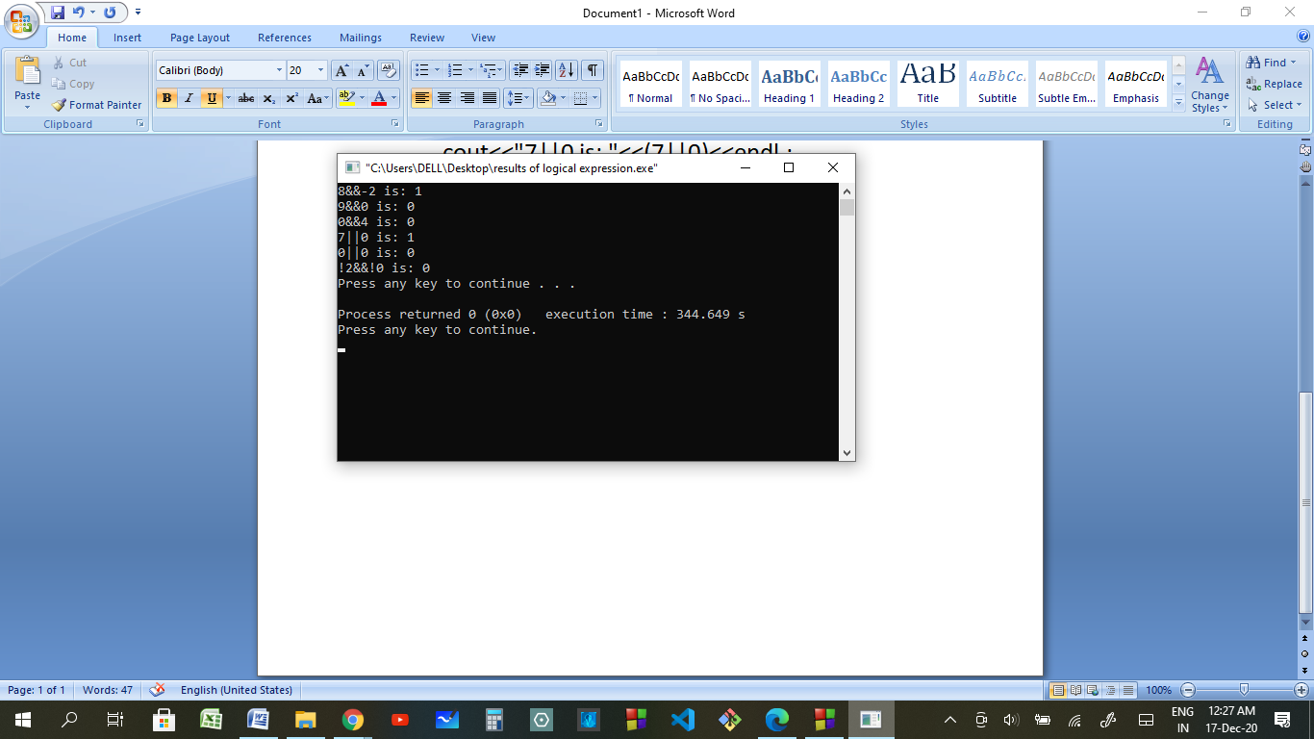

1. **To demonstrate the use of Relational operators.**

#include<iostream>

using namespace std;

int main(){

int a=5,b=4;

cout<<"a is 5 and b is 4"<<endl;

cout<<"a>b is "<<(a>b)<<endl;

cout<<"a<b is "<<(a<b)<<endl;

cout<<"a<=b is "<<(a<=b)<<endl;

cout<<"a>=b is "<<(a>=b)<<endl;

system("pause");

return 0;

}

**OUTPUT:**

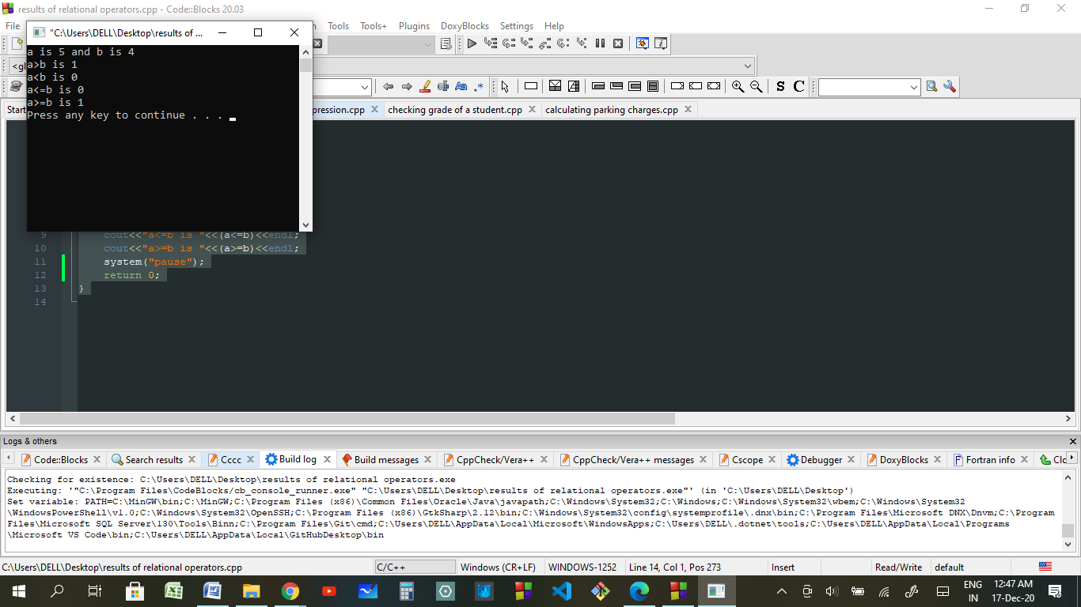

1. **To convert score into grade.**

#include<iostream>

using namespace std;

int main()

{

int a;

0<a<100;

cout<<"Enter Test Score between 0-100 to know your grade:";

cin>>a;

cout<<endl;

char grade;

if (a>=90)

{

grade='A';

cout<<"Your Grade is:"<<grade<<"\nCongratulations! Keep it up"<<endl;

}

else if (a>=80)

{

grade='B';

cout<<"Your Grade is:"<<grade<<"\nCongratulations! You have potential"<<endl;

}

else if (a>=70)

{

grade='C';

cout<<"Your Grade is:"<<grade<<"\nWork Hard, You can get it to top"<<endl;

}

else if (a>=60)

{

grade='D';

cout<<"Your Grade is:"<<grade<<"\nWork Hard, Better luck next time"<<endl;

}

else if (a>=50)

{

grade='E';

cout<<"Your Grade is:"<<grade<<"\nWork Hard, Better luck next time"<<endl;

}

else

{

grade='F';

cout<<"Your Grade is:"<<grade<<endl;

}

system("pause");

return 0;

}

**OUTPUT:**

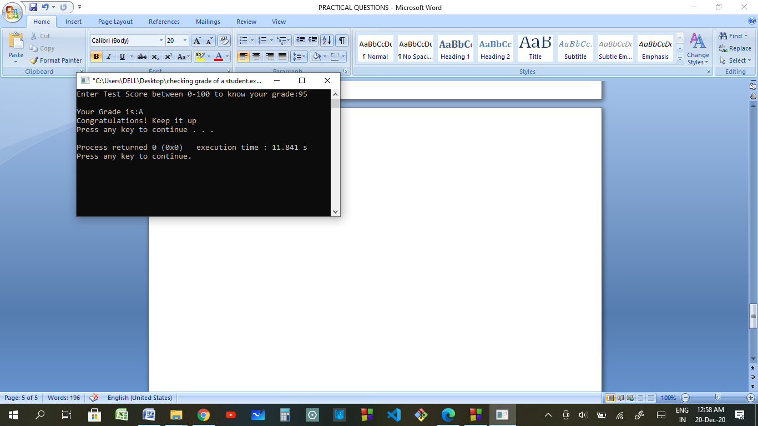

1. **To calculate charges of parking.**

#include<iostream>

#include<iomanip>

using namespace std;

int main()

{

cout<<"Enter the Type of vehicle- (C for Car/T for Truck/B for Bus: ";

char v;

cin>>v;

int hi,mi;

cout<<"Enter hour of Vehicle entry in 24 hour format - ";

cin>>hi;

cout<<"Enter minute of Vehicle Entry between 0 & 60 - ";

cin>>mi;

int ti;

ti=(hi*60)+mi;

int he,me;

cout<<"Enter hour of Vehicle Exit in 24 hour format - ";

cin>>he;

cout<<"Enter minute of Vehicle Exit between 0 & 60 - ";

cin>>me;

int te,ts,mmm;

float charge;

te=(he*60)+me;

ts=te-ti;

mmm=ts%60;

ts=int(ts/60);

if (v='c')

{

if (ts<=1)

{

charge=0;

}

else

{

charge=1.5;

}

}

else if (v='T')

{

if (ts<=3)

{

charge=1.0;

}

else

{

charge=3.5;

}

}

else if (v='B')

{

if (ts<=2)

{

charge=1.5;

}

else

{

charge=2.5;

}

}

cout<<endl<<endl<<endl<<endl;

cout<<"-------------------------------------------------------"<<endl;

cout<<"| Parking Ticket"<<setw(25)<<setfill(' ')<<"|"<<endl;

cout<<"|Vehicle Entry Time : "<<setw(2)<<setfill('0')<<hi<<":"<<setw(2)<<setfill('0')<<mi<<setw(26)<<setfill(' ')<<"|"<<endl;

cout<<"|Vehicle Exit Time : "<<setw(2)<<setfill('0')<<he<<":"<<setw(2)<<setfill('0')<<me<<setw(26)<<setfill(' ')<<"|"<<endl;

cout<<"| ---------------"<<setw(22)<<setfill(' ')<<"|"<<endl;

cout<<"|Vehicle Parking Time : "<<setw(2)<<setfill('0')<<ts<<":"<<setw(2)<<setfill('0')<<mmm<<setw(26)<<setfill(' ')<<"|"<<endl;

cout<<"|Net Hours Parked : "<<setw(2)<<setfill('0')<<ts<<" Hours"<<setw(23)<<setfill(' ')<<"|"<<endl;

cout<<"|Rate of Parking : "<<"$"<<left<<setw(3)<<setfill(' ')<<charge<<" perHour"<<right<<setw(19)<<setfill(' ')<<"|"<<endl;

cout<<"| ---------------"<<setw(22)<<setfill(' ')<<"|"<<endl;

cout<<"|Net Payable Amount : "<<"$"<<left<<setw(3)<<setfill(' ')<<float(ts*charge)<<right<<setw(27)<<setfill(' ')<<"|";

cout<<endl<<"|"<<setw(54)<<setfill(' ')<<"|"<<endl;

cout<<"| -----Please Visit Again-----"<<setw(17)<<setfill(' ')<<"|"<<endl;

cout<<"|-----------------------------------------------------|"<<endl;

cout<<endl<<endl<<endl;

system("pause");

return 0;

}

**OUTPUT:**

